# Set up Named Credentials for a callout which uses OAuth Client Credentials flow

# Code without Named Creds

String endpoint = 'https://anypoint.mulesoft.com/api/v1/organizations/'+settings.organisation_Id__c+'/environments/'+settings.environment_Id__c+'/destinations/'+settings.destination__c+'/messages/'+uniqueId;

HttpRequest req = new HttpRequest();

req.setEndpoint(endpoint); //goes into Named Credential

req.setMethod('PUT');

req.setHeader('Content-Type', 'application/json');

req.setHeader('Cache-Control', 'no-cache');

req.setHeader('Authorization', 'Bearer ' + getAccessToken());

req.setBody(jsonString);

Http http = new Http();

HttpResponse response = http.send(req);

public static String getAccessToken() {

HttpRequest req = new HttpRequest();

req.setEndpoint('https://anypoint.mulesoft.com/api/v1/authorize'); // this goes into Ext creds

req.setMethod('POST');

req.setHeader('Content-Type', 'application/x-www-form-urlencoded');

String clientId = '' ;

String clientSecret = '';

req.setBody('client_id=' + clientId + '&client_secret=' + clientSecret + '&grant_type=client_credentials');

Http http = new Http();

HTTPResponse res = http.send(req);

Map<String, Object> responseMap = (Map<String, Object>) JSON.deserializeUntyped(res.getBody());

return (String)responseMap.get('access_token');

}

## With Named Creds

String endpoint = api/v1/organizations/'+settings.organisation_Id__c+'/environments/'+settings.environment_Id__c+'/destinations/'+settings.destination__c+'/messages/'+uniqueId;

HttpRequest req = new HttpRequest();

req.setEndpoint('callout:NamedCreds/'+endpoint);

req.setMethod('PUT');

req.setHeader('Content-Type', 'application/json');

req.setHeader('Cache-Control', 'no-cache');

req.setBody(mulesoftPayload);

Http http = new Http();

HttpResponse response = http.send(req);

## External Creds

Add URL here

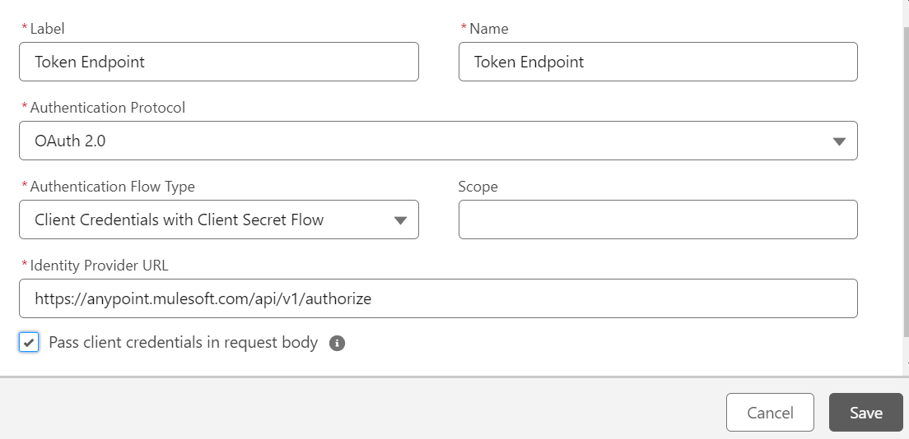

Add client id and secrete in the related list

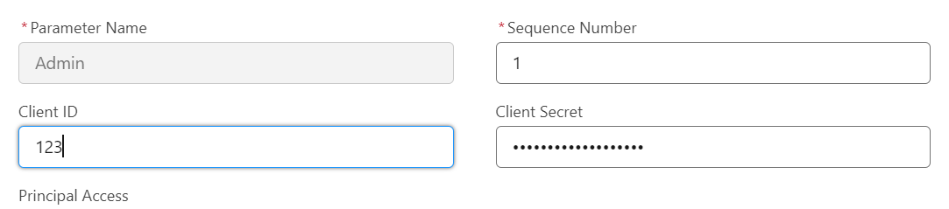

## Named Creds

Add the endpoint here and assign the External Credential

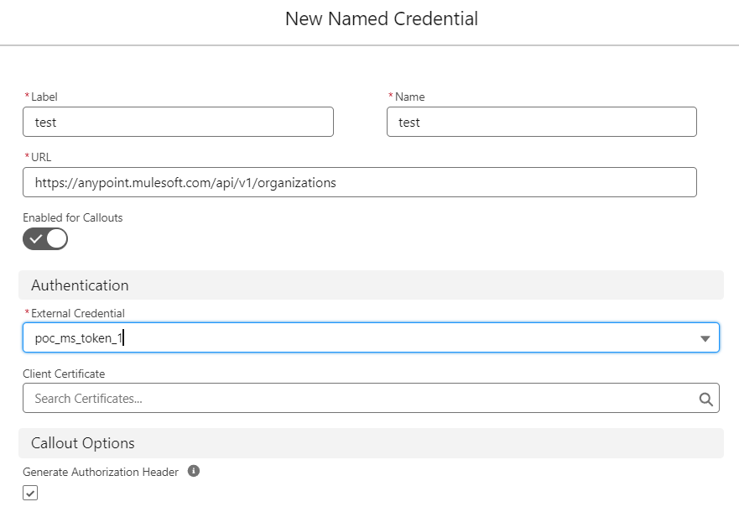

# API KEY Authorization

## Without Named Credentials

HttpRequest request = new HttpRequest();

request.setEndpoint(apiUrl); //this goes into Named Credential

request.setMethod('POST');

request.setHeader('Content-Type', 'application/json');

request.setHeader('DD-API-KEY', apiKey);// this goes into External Credential

request.setBody(jsonPayload);

Http http = new Http();

HttpResponse response = http.send(request);

## With Named Credentials

### External Credential

Authentication protocol = Custom

* The key as a Principal

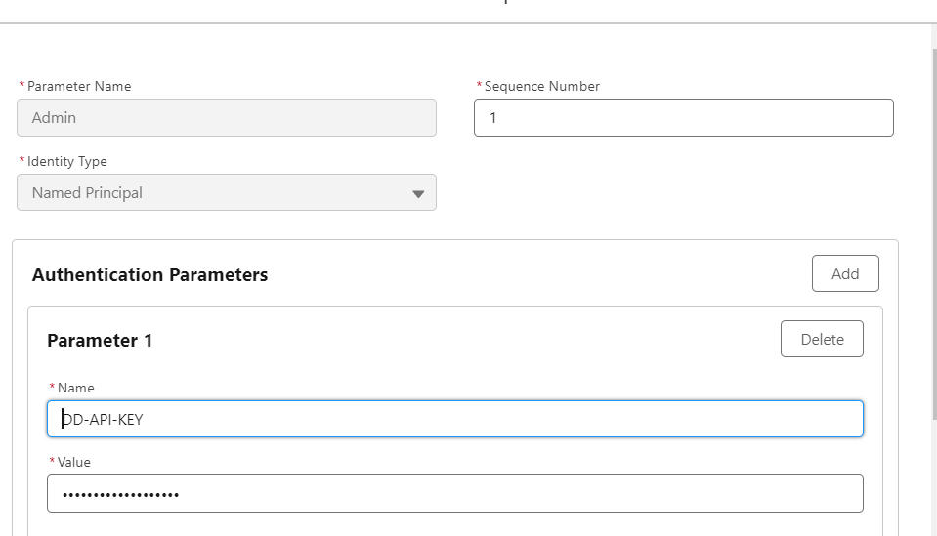

In the Named credentials

* Give URL and External Credential
* No generate authorization header